

Mobile Application Development

Lab 4



Muhammad daniyal Qureshi

021-18-0009

BSCS-VII

Contents

Activity 1: Create a Login Page 1

**Layout** 1

**Logic Code** 5

**Output** 7

Activity 2: Friendsr App 9

**Layout** 9

**Logic Code** 13

**Output** 17

Activity 3: Mid Labs 19

**Layout** 19

**Logic Code** 22

**Output** 27

# Activity 1: Create a Login Page

## **Layout**

<?xml version="1.0" encoding="utf-8"?>

<LinearLayout xmlns:android="http://schemas.android.com/apk/res/android"

    xmlns:app="http://schemas.android.com/apk/res-auto"

    xmlns:tools="http://schemas.android.com/tools"

    android:layout_width="match_parent"

    android:layout_height="match_parent"

    android:background="#125312"

    android:orientation="vertical"

    tools:context=".MainActivity">

    <EditText

        android:id="@+id/Email"

        android:layout_width="match_parent"

        android:layout_height="50dp"

        android:layout_gravity="center"

        android:layout_marginLeft="20dp"

        android:layout_marginTop="200dp"

        android:layout_marginRight="20dp"

        android:layout_weight="0"

        android:background="@color/white"

        android:hint="Email"

        android:inputType="textEmailAddress" />

    <EditText

        android:id="@+id/password"

        android:layout_width="match_parent"

        android:layout_height="50dp"

        android:layout_gravity="center"

        android:layout_marginLeft="20dp"

        android:layout_marginTop="20dp"

        android:layout_marginRight="20dp"

        android:layout_weight="0"

        android:background="@color/white"

        android:hint="Password"

        android:inputType="textPassword"

        />

    <Button

        android:id="@+id/button"

        android:layout_width="match_parent"

        android:layout_height="70dp"

        android:layout_gravity="center"

        android:layout_marginLeft="20dp"

        android:layout_marginTop="20dp"

        android:layout_marginRight="20dp"

        android:layout_weight="0"

        android:backgroundTint="@color/white"

        android:text="Login"

        android:textColor="#125312"

        android:onClick="login"

        />

    <TextView

        android:id="@+id/textView"

        android:layout_width="wrap_content"

        android:layout_height="wrap_content"

        android:layout_gravity="center"

        android:layout_marginTop="100dp"

        android:layout_weight="0"

        android:onClick="signup"

        android:text="Not a member ? Sign up now"

        android:textColor="@color/white"

        android:textSize="20sp" />

</LinearLayout>

<?xml version="1.0" encoding="utf-8"?>

<LinearLayout xmlns:android="http://schemas.android.com/apk/res/android"

    xmlns:app="http://schemas.android.com/apk/res-auto"

    xmlns:tools="http://schemas.android.com/tools"

    android:layout_width="match_parent"

    android:layout_height="match_parent"

    android:background="#1D2E1D"

    android:orientation="vertical"

    tools:context=".Signup">

    <EditText

        android:id="@+id/Name"

        android:layout_width="match_parent"

        android:layout_height="50dp"

        android:layout_gravity="center"

        android:layout_marginLeft="20dp"

        android:layout_marginTop="200dp"

        android:layout_marginRight="20dp"

        android:layout_weight="0"

        android:background="#808080"

        android:hint="Fullname"

        android:inputType="textPersonName" />

    <EditText

        android:id="@+id/Email"

        android:layout_width="match_parent"

        android:layout_height="50dp"

        android:layout_gravity="center"

        android:layout_marginLeft="20dp"

        android:layout_marginTop="20dp"

        android:layout_marginRight="20dp"

        android:layout_weight="0"

        android:background="#808080"

        android:hint="Email"

        android:inputType="textEmailAddress" />

    <EditText

        android:id="@+id/password"

        android:layout_width="match_parent"

        android:layout_height="50dp"

        android:layout_gravity="center"

        android:layout_marginLeft="20dp"

        android:layout_marginTop="20dp"

        android:layout_marginRight="20dp"

        android:layout_weight="0"

        android:background="#808080"

        android:hint="Password"

        android:inputType="textPassword"

        />

    <Button

        android:id="@+id/button"

        android:layout_width="match_parent"

        android:layout_height="70dp"

        android:layout_gravity="center"

        android:layout_marginLeft="20dp"

        android:layout_marginTop="20dp"

        android:layout_marginRight="20dp"

        android:layout_weight="0"

        android:backgroundTint="#FF1493"

        android:onClick="signup"

        android:text="Register"

        android:textColor="@color/white" />

    <TextView

        android:id="@+id/textView"

        android:layout_width="wrap_content"

        android:layout_height="wrap_content"

        android:layout_gravity="center"

        android:layout_marginTop="90dp"

        android:layout_weight="0"

        android:text="Already registered !Login Me."

        android:textColor="@color/white"

        android:textSize="20sp"

        android:onClick="login"

        />

</LinearLayout>

## **Logic Code**

package com.example.login;

import androidx.appcompat.app.AppCompatActivity;

import android.content.Intent;

import android.content.SharedPreferences;

import android.os.Bundle;

import android.util.Log;

import android.view.View;

import android.widget.EditText;

import android.widget.Toast;

public class MainActivity extends AppCompatActivity {

    @Override

    protected void onCreate(Bundle savedInstanceState) {

        super.onCreate(savedInstanceState);

        setContentView(R.layout.activity_main);

    }

    public void login(View view){

        EditText Email=(EditText)findViewById(R.id.Email);

        EditText Password=(EditText)findViewById(R.id.password);

        SharedPreferences prefs=getSharedPreferences("user",MODE_PRIVATE);

        String d=prefs.getString(Email.getText().toString(),"none");

        Log.i("val",d);

        if(d.equals(Password.getText().toString()))

            Toast.makeText(this,"Login Successfully",Toast.LENGTH_LONG).show();

        else

            Toast.makeText(this, "Sign up first", Toast.LENGTH_LONG).show();

    }

    public void signup(View view){

    Intent intent=new Intent(this,Signup.class);

    startActivity(intent);

    }

}

package com.example.login;

import androidx.appcompat.app.AppCompatActivity;

import android.content.Intent;

import android.content.SharedPreferences;

import android.os.Bundle;

import android.view.View;

import android.widget.EditText;

import android.widget.Toast;

public class Signup extends AppCompatActivity {

    @Override

    protected void onCreate(Bundle savedInstanceState) {

        super.onCreate(savedInstanceState);

        setContentView(R.layout.activity_signup);

    }

    public void signup(View view){

        EditText Email=(EditText)findViewById(R.id.Email);

        EditText Password=(EditText)findViewById(R.id.password);

        SharedPreferences prefs=getSharedPreferences("user",MODE_PRIVATE);

        SharedPreferences.Editor editor=prefs.edit();

        editor.putString(Email.getText().toString(),Password.getText().toString());

        editor.commit();

        Toast.makeText(this,"You are registered",Toast.LENGTH_LONG).show();

    }

    public void login(View view){

    Intent intent=new Intent(this,MainActivity.class);

    startActivity(intent);

    }

}

## **Output**

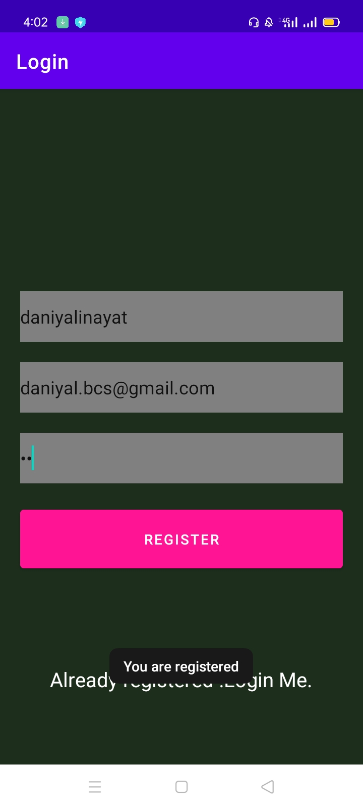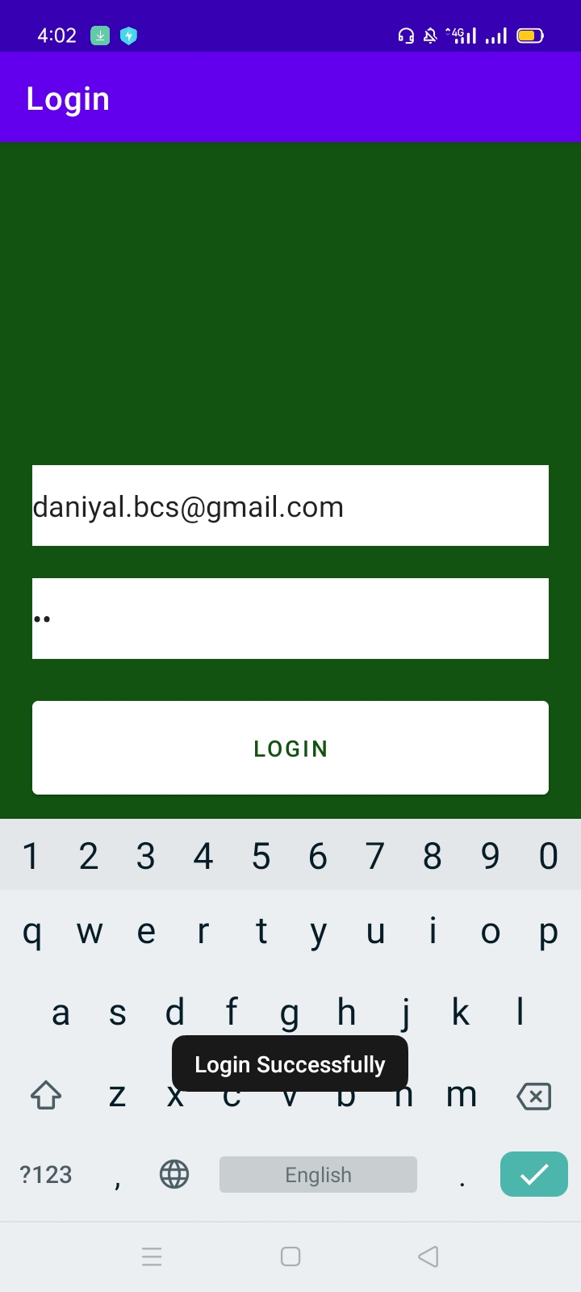

# Activity 2: Friendsr App

## **Layout**

<?xml version="1.0" encoding="utf-8"?>

<ScrollView xmlns:android="http://schemas.android.com/apk/res/android"

    xmlns:tools="http://schemas.android.com/tools"

    android:layout_width="match_parent"

    android:layout_height="match_parent"

    android:scrollbarSize="25sp"

    tools:context=".Details">

<LinearLayout

    android:layout_width="match_parent"

    android:layout_height="match_parent"

    android:orientation="vertical"

    tools:context=".Details"

    android:padding="10dp"

    >

    <RatingBar

        android:id="@+id/rating"

        android:layout_width="wrap_content"

        android:layout_height="wrap_content"

        android:layout_gravity="center"

        android:numStars="5" />

    <ImageView

        android:id="@+id/imageView"

        android:layout_width="wrap_content"

        android:layout_height="wrap_content"

        android:layout_gravity="center"

        tools:srcCompat="@tools:sample/avatars" />

    <TextView

        android:id="@+id/txt"

        android:layout_width="wrap_content"

        android:layout_height="wrap_content"

        android:layout_gravity="center"

        android:text="TextView"

        android:textSize="24sp" />

</LinearLayout>

</ScrollView>

<?xml version="1.0" encoding="utf-8"?>

<LinearLayout xmlns:android="http://schemas.android.com/apk/res/android"

    xmlns:app="http://schemas.android.com/apk/res-auto"

    xmlns:tools="http://schemas.android.com/tools"

    android:layout_width="match_parent"

    android:layout_height="match_parent"

    android:layout_marginTop="50dp"

    android:orientation="vertical"

    tools:context=".MainActivity">

    <TextView

        android:id="@+id/textView"

        android:layout_width="wrap_content"

        android:layout_height="wrap_content"

        android:layout_gravity="center"

        android:layout_weight="0"

        android:text="Friends"

        android:textSize="36sp"

        android:textStyle="bold" />

    <TextView

        android:id="@+id/textView2"

        android:layout_width="match_parent"

        android:layout_height="wrap_content"

        android:layout_weight="0"

        android:text="Click on an eligible single user to learn more and see if you are compatible  for a date!"

        android:textSize="18sp" />

    <LinearLayout

        android:layout_width="match_parent"

        android:layout_height="wrap_content"

        android:layout_weight="0"

        android:orientation="horizontal">

        <LinearLayout

            android:layout_width="match_parent"

            android:layout_height="match_parent"

            android:layout_marginStart="20dp"

            android:layout_marginLeft="20dp"

            android:layout_weight="1"

            android:gravity="center"

            android:orientation="vertical">

            <ImageButton

                android:id="@+id/ImageButton"

                android:layout_width="wrap_content"

                android:layout_height="wrap_content"

                app:srcCompat="@drawable/chandlersmall"

                android:onClick="change"

                android:tag="1"

                />

            <TextView

                android:id="@+id/textView3"

                android:layout_width="wrap_content"

                android:layout_height="wrap_content"

                android:text="Chandler" />

            <ImageButton

                android:id="@+id/ImageButton3"

                android:layout_width="wrap_content"

                android:layout_height="wrap_content"

                app:srcCompat="@drawable/monicasmall"

                android:onClick="change"

                android:tag="2"

                />

            <TextView

                android:id="@+id/textView4"

                android:layout_width="wrap_content"

                android:layout_height="wrap_content"

                android:text="Monica" />

            <ImageButton

                android:id="@+id/ImageButton4"

                android:layout_width="wrap_content"

                android:layout_height="wrap_content"

                app:srcCompat="@drawable/rachelsmall"

                android:onClick="change"

                android:tag="3"

                />

            <TextView

                android:id="@+id/textView5"

                android:layout_width="wrap_content"

                android:layout_height="wrap_content"

                android:text="Rachel" />

        </LinearLayout>

        <LinearLayout

            android:layout_width="match_parent"

            android:layout_height="match_parent"

            android:layout_marginEnd="20dp"

            android:layout_marginRight="20dp"

            android:layout_weight="1"

            android:gravity="center"

            android:orientation="vertical">

            <ImageButton

                android:id="@+id/ImageButton2"

                android:layout_width="wrap_content"

                android:layout_height="wrap_content"

                android:onClick="change"

                android:tag="4"

                app:srcCompat="@drawable/joeysmall"

                />

            <TextView

                android:id="@+id/textView6"

                android:layout_width="wrap_content"

                android:layout_height="wrap_content"

                android:text="Joey" />

            <ImageButton

                android:id="@+id/ImageButton5"

                android:layout_width="wrap_content"

                android:layout_height="wrap_content"

                android:onClick="change"

                android:tag="5"

                app:srcCompat="@drawable/phoebesmall"

                />

            <TextView

                android:id="@+id/textView7"

                android:layout_width="wrap_content"

                android:layout_height="wrap_content"

                android:text="Phoebe" />

            <ImageButton

                android:id="@+id/ImageButton6"

                android:layout_width="wrap_content"

                android:layout_height="wrap_content"

                android:onClick="change"

                android:tag="6"

                app:srcCompat="@drawable/rosssmall"

                />

            <TextView

                android:id="@+id/textView8"

                android:layout_width="wrap_content"

                android:layout_height="wrap_content"

                android:text="Ross" />

        </LinearLayout>

    </LinearLayout>

</LinearLayout>

## **Logic Code**

package com.example.friendsapp;

import androidx.appcompat.app.AppCompatActivity;

import android.content.Intent;

import android.content.SharedPreferences;

import android.media.Image;

import android.os.Bundle;

import android.util.Log;

import android.view.View;

import android.widget.ImageView;

import android.widget.RatingBar;

import android.widget.TextView;

public class Details extends AppCompatActivity {

    String name;

    Intent intent;

    float Rating;

    @Override

    protected void onCreate(Bundle savedInstanceState) {

        super.onCreate(savedInstanceState);

        setContentView(R.layout.activity_details);

        intent =getIntent();

        String tag=intent.getStringExtra("tag");

        ImageView img=(ImageView) findViewById(R.id.imageView);

        TextView txt=(TextView)findViewById(R.id.txt);

        RatingBar ratingBar=(RatingBar)findViewById(R.id.rating);

        String[] str=getResources().getStringArray(R.array.friend_details);

        SharedPreferences prefs=getSharedPreferences("user",MODE_PRIVATE);

        Rating=0;

        if(tag.equals("1"))

        {

        img.setImageResource(R.drawable.chandler);

        txt.setText(str[0]);

        name="chandler";

        }

        else if(tag.equals("2"))

        {

            img.setImageResource(R.drawable.monica);

            txt.setText(str[2]);

            name="monica";

        }

        else if(tag.equals("3"))

        {

            img.setImageResource(R.drawable.rachel);

            txt.setText(str[4]);

            name="rachel";

        }

        else if(tag.equals("4"))

        {

            img.setImageResource(R.drawable.joey);

            txt.setText(str[1]);

            name="joey";

        }

        else if(tag.equals("5"))

        {

            img.setImageResource(R.drawable.phoebe);

            txt.setText(str[3]);

            name="phoebe";

        }

        else if(tag.equals("6"))

        {

            img.setImageResource(R.drawable.ross);

            txt.setText(str[5]);

            name="ross";

        }

        String d=prefs.getString(name,"none");

        if(!d.equals("none")) {

            ratingBar.setRating(Float.parseFloat(d));

            Rating=Float.parseFloat(d);

        }

        ratingBar.setOnRatingBarChangeListener(new RatingBar.OnRatingBarChangeListener() {

            @Override

            public void onRatingChanged(RatingBar ratingBar, float rating, boolean fromUser) {

                SharedPreferences prefs=getSharedPreferences("user",MODE_PRIVATE);

                SharedPreferences.Editor editor=prefs.edit();

                editor.putString(name,""+rating);

                Rating=rating;

                editor.commit();

                intent.putExtra("rate",""+Rating);

            }

        });

        intent.putExtra("rate",""+Rating);

        Log.i("value",""+Rating);

        setResult(123, intent);

    }

    @Override

    public void onBackPressed() {

        super.onBackPressed();

        finish();

    }

}

package com.example.friendsapp;

import androidx.annotation.Nullable;

import androidx.appcompat.app.AppCompatActivity;

import android.content.Intent;

import android.media.Image;

import android.os.Bundle;

import android.view.View;

import android.widget.Button;

import android.widget.ImageButton;

import android.widget.Toast;

public class MainActivity extends AppCompatActivity {

    @Override

    protected void onCreate(Bundle savedInstanceState) {

        super.onCreate(savedInstanceState);

        setContentView(R.layout.activity_main);

    }

    public void change(View view){

        ImageButton btn=(ImageButton)view;

        Intent intent=new Intent(this,Details.class);

        intent.putExtra("tag",btn.getTag().toString());

    startActivityForResult(intent,123);

    }

    @Override

    protected void onActivityResult(int requestCode, int resultCode, @Nullable Intent data) {

        super.onActivityResult(requestCode, resultCode, data);

        if(requestCode==123)

        {

            String returnString = data.getStringExtra("rate");

            Toast.makeText(this,"You rated "+returnString,Toast.LENGTH_LONG).show();

        }

    }

}

# **Output**

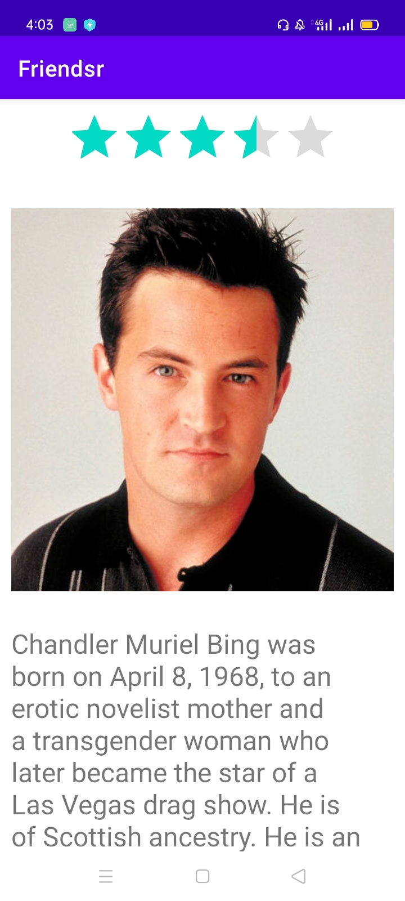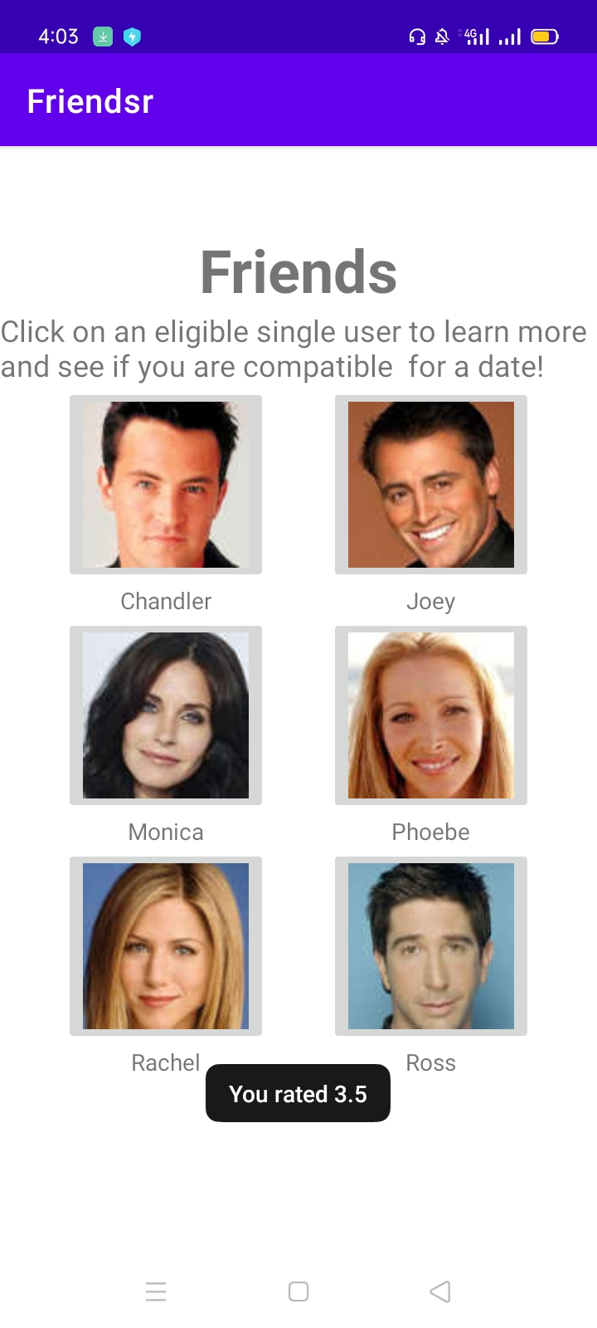

# Activity 3: Mid Labs

## **Layout**

<?xml version="1.0" encoding="utf-8"?>

<LinearLayout xmlns:android="http://schemas.android.com/apk/res/android"

    xmlns:app="http://schemas.android.com/apk/res-auto"

    xmlns:tools="http://schemas.android.com/tools"

    android:layout_width="match_parent"

    android:layout_height="match_parent"

    android:orientation="vertical"

    tools:context=".MainActivity">

    <ImageView

        android:id="@+id/imageView"

        android:layout_width="match_parent"

        android:layout_height="wrap_content"

        app:srcCompat="@drawable/cover" />

    <TextView

        android:id="@+id/textView"

        android:layout_width="match_parent"

        android:layout_height="wrap_content"

        android:gravity="center"

        android:padding="10dp"

        android:text="Welcome to Mad Libs! I will ask you to fill in words to complete the story until you are done filling in all the missing words. That's part of the fun. Click below to get started..."

        android:textColor="@color/black"

        android:textSize="18sp" />

    <Button

        android:id="@+id/btnst"

        android:layout_width="wrap_content"

        android:layout_height="wrap_content"

        android:layout_gravity="right"

        android:onClick="start"

        android:text="GET STARTED!"

        android:textColor="@color/black"

        android:textSize="30sp"

        android:textStyle="bold"

        android:backgroundTint="#808080"

        />

</LinearLayout>

<?xml version="1.0" encoding="utf-8"?>

<ScrollView xmlns:android="http://schemas.android.com/apk/res/android"

    xmlns:app="http://schemas.android.com/apk/res-auto"

    xmlns:tools="http://schemas.android.com/tools"

    android:layout_width="match_parent"

    android:layout_height="match_parent"

    android:fillViewport="true"

    tools:context=".story">

<LinearLayout

    android:layout_width="match_parent"

    android:layout_height="match_parent"

    android:orientation="vertical"

    >

    <TextView

        android:id="@+id/textView4"

        android:layout_width="wrap_content"

        android:layout_height="wrap_content"

        android:layout_gravity="center"

        android:layout_weight="0"

        android:text="Your Mad Lib Story"

        android:textSize="36sp"

        android:textStyle="bold" />

    <TextView

        android:id="@+id/textView5"

        android:layout_width="match_parent"

        android:layout_height="wrap_content"

        android:layout_weight="0"

        android:text="TextView"

        android:textSize="30sp" />

    <Button

        android:id="@+id/button2"

        android:layout_width="match_parent"

        android:layout_height="wrap_content"

        android:layout_weight="0"

        android:onClick="another"

        android:text="MAKE ANOTHER STORY"

        android:textSize="24sp"

        app:backgroundTint="#808080" />

</LinearLayout>

</ScrollView>

<?xml version="1.0" encoding="utf-8"?>

<LinearLayout xmlns:android="http://schemas.android.com/apk/res/android"

    xmlns:app="http://schemas.android.com/apk/res-auto"

    xmlns:tools="http://schemas.android.com/tools"

    android:layout_width="match_parent"

    android:layout_height="match_parent"

    android:orientation="vertical"

    tools:context=".words">

    <TextView

        android:id="@+id/textView3"

        android:layout_width="wrap_content"

        android:layout_height="wrap_content"

        android:text="Fill in words to complete the story"

        android:textSize="40sp"

        />

    <TextView

        android:id="@+id/leftwords"

        android:layout_width="wrap_content"

        android:layout_height="wrap_content"

        android:textSize="20sp"

        android:layout_gravity="center"

        android:text="TextView"

        android:layout_marginTop="30dp"

        />

<LinearLayout

    android:layout_width="match_parent"

    android:layout_height="wrap_content"

    android:layout_marginTop="20dp"

    >

    <EditText

        android:id="@+id/editext"

        android:layout_width="wrap_content"

        android:layout_height="wrap_content"

        android:ems="10"

        android:inputType="textPersonName"

        android:hint="noun"

        android:layout_marginRight="20dp"

        android:layout_marginLeft="20dp"

        />

    <Button

        android:id="@+id/button"

        android:layout_width="wrap_content"

        android:layout_height="wrap_content"

        android:text="OK"

        android:onClick="Ok"

        android:textColor="@color/black"

        android:backgroundTint="#808080"

        />

</LinearLayout>

    <TextView

        android:layout_width="wrap_content"

        android:layout_height="wrap_content"

        android:layout_gravity="center"

        android:textSize="20sp"

        android:id="@+id/word"

        android:text="please type a/an noun"

        />

</LinearLayout>

## **Logic Code**

package com.example.midlabs;

import androidx.appcompat.app.AppCompatActivity;

import android.content.Intent;

import android.os.Bundle;

import android.view.View;

public class MainActivity extends AppCompatActivity {

    @Override

    protected void onCreate(Bundle savedInstanceState) {

        super.onCreate(savedInstanceState);

        setContentView(R.layout.activity_main);

    }

    public void start(View view){

        Intent intent=new Intent(this,words.class);

        startActivity(intent);

    }

}

package com.example.midlabs;

import androidx.appcompat.app.AppCompatActivity;

import android.content.Intent;

import android.os.Bundle;

import android.widget.TextView;

import org.w3c.dom.Text;

public class story extends AppCompatActivity {

    @Override

    protected void onCreate(Bundle savedInstanceState) {

        super.onCreate(savedInstanceState);

        setContentView(R.layout.activity_story);

        Intent intent=getIntent();

        String story=intent.getStringExtra("story");

        TextView txt=(TextView)findViewById(R.id.textView5);

        txt.setText(story);

    }

}

package com.example.midlabs;

import androidx.appcompat.app.AppCompatActivity;

import android.content.Intent;

import android.os.Bundle;

import android.text.TextUtils;

import android.util.Log;

import android.view.View;

import android.widget.EditText;

import android.widget.TextView;

import android.widget.Toast;

import java.util.ArrayList;

import java.util.List;

import java.util.Random;

import java.util.regex.Matcher;

import java.util.regex.Pattern;

public class words extends AppCompatActivity {

    String stories[];

    TextView leftwords,placingwords;

    EditText editText;

    ArrayList<String> matches;

    String story;

    int counter,index;

    @Override

    protected void onCreate(Bundle savedInstanceState) {

        super.onCreate(savedInstanceState);

        setContentView(R.layout.activity_words);

        leftwords=(TextView)findViewById(R.id.leftwords);

        placingwords=(TextView)findViewById(R.id.word);

        editText=(EditText) findViewById(R.id.editext);

        stories=new String[]{"I wannabe a <job> when I grow up.Just like my dad.Life is <adjective> like that!"

        ,"One of the most <adjective> characters in fiction is named\n" +

                "Tarzan of the <plural-noun> . Tarzan was raised by a/an\n" +

                "<noun> and lives in the <adjective> jungle in the\n" +

                "heart of darkest <place> . He spends most of his time\n" +

                "eating <plural-noun> and swinging from tree to <noun> .\n" +

                "Whenever he gets angry, he beats on his chest and says,\n" +

                " <funny-noise> ! This is his war cry. Tarzan always dresses in\n" +

                "<adjective> shorts made from the skin of a/an <noun>\n" +

                "and his best friend is a/an <adjective> chimpanzee named\n" +

                "Cheetah. He is supposed to be able to speak to elephants and\n" +

                "<plural-noun> . In the movies, Tarzan is played by <person's-name> ."

                ,

                "Our American universities offer students many <adjective>\n" +

                        "courses that will prepare them to become professional <plural-noun> .\n" +

                        "You can get a degree as a Bachelor of <plural-noun> or take a\n" +

                        "regular liberal <plural-noun> course. Or, if you want to become\n" +

                        "a/an <adjective> engineer, you can study <adjective> mathematics\n" +

                        "and differential <plural-noun> . Then, after <number> years, if\n" +

                        "you want to continue your studies you can write a/an <noun> and\n" +

                        "become a Doctor of <plural-noun> . \n" +

                        "\n" +

                        "When you get out into the <adjective> world, if you have a diploma \n" +

                        "from a university, you will be able to get a job easily as a/an <job-title> \n" +

                        "or even a/an <job-title> . If you don't have a diploma, you may have to take\n" +

                        "a job as a <noun> . \n" +

                        "\n" +

                        "Remember, it's important that you study hard in high school so you are able \n" +

                        "to do well on your college entrance <plural-noun> . It is true that \"a little \n" +

                        "learning is a/an <adjective> thing.",

                "<Male-Name> has announced that his <adjective>\n" +

                        "clothing store in the heart of downtown <CITY> is having\n" +

                        "a/an <adjective> sale of all merchandise, including\n" +

                        "<unusual-adjective> suits and slightly irregular <plural-noun>\n" +

                        "available. Men's cable-knit <plural-noun> , only $15.99.\n" +

                        "Hand-woven Italian <plural-noun> , 1/2-price. Double-\n" +

                        "breasted cashmere <plural-noun> , $50.00. Genuine imported\n" +

                        "<Color!> <adjective> shoes, <Exciting-adjective> handerchiefs,\n" +

                        "and women's embroidered <plural-noun> , all at rock-bottom prices.\n" +

                        "This is a chance to get some really <Interesting-Adjective> bargains."

                ,"Here's how you dance the Monstrosity. Stand with your feet together.\n" +

                "Now, move your left foot <aDvErB> to the side. Now stamp your\n" +

                "right foot <NUMBER> times and put your hands on your partner's\n" +

                "<Plural-Noun> . Next, you both <verb> slowly to the right and bend\n" +

                "your <body-part> backward. For the next eight counts,\n" +

                "both of you <verb> <adverb> to the left. Next, you and\n" +

                "your partner stand back to back and wiggle your <pluRAL-nOUN> and\n" +

                "slap your <plural-noun> together. Don't forget to keep stamping\n" +

                "your right foot. Now, face your partner again, put your <plural-noun>\n" +

                "together and shout,  <FUNNY-noise> ! Now, <verb> backward\n" +

                "and repeat the whole thing <Number> times. If you feel that you can't\n" +

                "learn this dance, you can always <verB> the next one out."

        };

        story=stories[new Random().nextInt(5)];

        Pattern pattern = Pattern.compile("\\<(.*?)\\>");

        Matcher matcher = pattern.matcher(story);

        matches = new ArrayList<String>();

        while(matcher.find())

            matches.add(matcher.group());

        counter=matches.size();

        index=0;

        leftwords.setText(counter +"words(s) left");

        String w=matches.get(index);

        w=w.replace("<","");

        w=w.replace(">","");

        placingwords.setText("please type a/an "+w);

        editText.setHint(w);

        Log.i("dic",matches.toString());

    }

    public  void Ok(View view){

        if(TextUtils.isEmpty(editText.getText().toString()))

        {

            editText.setError("Empty field");

            return;

        }

        Toast.makeText(this,"Great keep  going",Toast.LENGTH_LONG).show();

        leftwords.setText(--counter +"words(s) left");

        String w=matches.get(index);

        story=story.replaceFirst(w,editText.getText().toString());

        if(counter==0)

        {

            Intent intent=new Intent(this,story.class);

            intent.putExtra("story",story);

            startActivity(intent);

        }

        Log.i("story",story);

        w=matches.get(++index);

        w=w.replace("<","");

        w=w.replace(">","");

        placingwords.setText("please type a/an "+w);

        editText.setHint(w);

        editText.setText("");

    }

    public void another(View view){

        finish();

    }

}

## **Output**

